Vdp waveforms:
Modelsim
- Assembler Block
About the waveform:

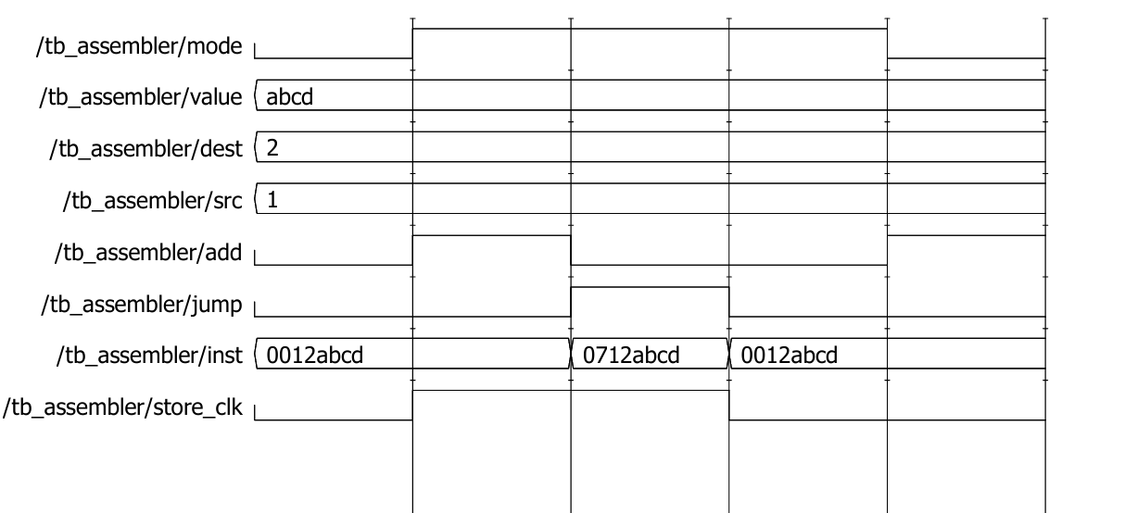

Fig 1.1.Assembler waveform captured in modelsim

- EEPROM Block

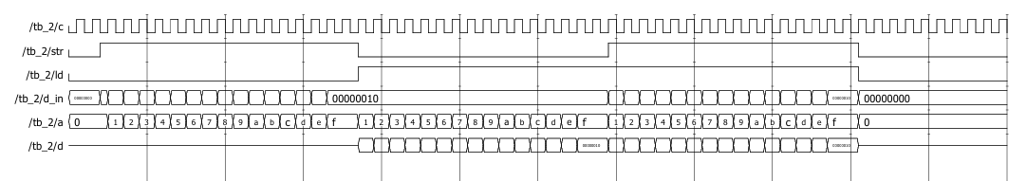
- Decoder Block

4.

